2012 tour
Saturday and Sunday, May 5th and 6th
1 p.m. - 5 p.m.

The Tour of Homes is sponsored by The Heritage Association of San Marcos, which was founded in 1975 to enrich and beautify the community through historical and cultural preservation.
The Robertson House  Home of  James & Deb Robertson  1202 West Hopkins Street | 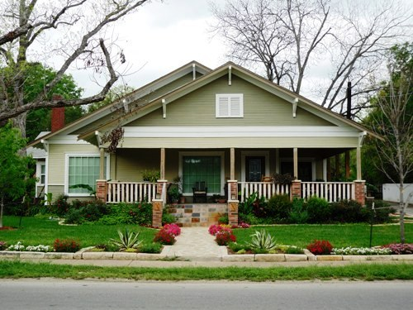
When Deb and James Robertson purchased their home at 1202 West Hopkins Street, they didn’t intend to make it their permanent residence. In fact, the original plan was to make some improvements on the house and “flip” it for a profit.
But after spending most of 2010 on the renovation project, the Robertsons discovered they had grown quite attached to the house and decided not to put it on the market after all. Instead, they sold their home in Martindale and moved to San Marcos, where their little Hopkins Street “project” had become a labor of love.
Although the Robertsons’ address is on West Hopkins, it is included within the Belvin Street Historic District. It was built in 1924 by Mr. and Mrs. A.E. Cheeseboro, a bakery owner in early San Marcos, on land purchased for San Marcos in 1845 by General Edward Burleson and Dr. Eli Merriman. The land was originally part of a Spanish land grant awarded to Juan Vientie Campos.
A craftsman-style home, the exterior architecture was not significantly altered during the renovation process. In fact, the Robertsons took care to change those features, such as the wrought-iron railings on the porch, that had been added to the home in the 1950’s, but were not in keeping with the 1920’s style. They also spent extra funds to have the original garage rebuilt rather than tearing it down completely.
What did undergo change, however, was the home’s interior. The owners took part of a 25-foot long hallway to add a butler’s pantry, for example, and they relocated the master bedroom from the front of the home to the back, where traffic noise would be reduced. One of two other bedrooms was turned into a large master bath, and the kitchen was also expanded.
During the renovation, the Robertsons made an effort to use period-style materials as much as possible. They took out most of the interior doors, but replaced them with similar style doors. They also added pedestal sinks in the bathrooms to retain the nostalgic look and replaced some rotted floor boards with pine planks from the same era.
Much of the furniture in the home was custom built by James, who owns Native Furniture Works in Martindale. James, with help from Deb, is also responsible for the beautiful landscaping in the front yard, recognized in April as the “Yard of the Month” by the Spring Lake Garden Club.
James explained that while most people load up their furniture when moving to a new house, he and Deb leave most of their furniture (since it is custom made for each home) and take their plants instead. “We have some cannas that came originally from Abilene, were transplanted to Lockhart, then were moved to our yard in Martindale and now have made their way to Hopkins Street,” James explained.
Some flag plants made a similar journey from the yard of James’s grandmother in Comanche, and there are some ivy plants that started their life in Nacogdoches, where Deb’s mother lives. “We also have some cacti that have made four or five moves before being planted here,” James said.
In time, the Robertsons’ back yard will be as stunning as the front. Currently a work in progress, James said they have added sidewalks and hope to also add an outdoor kitchen and privacy fencing. They have planted a vegetable garden as well as an oak tree and will soon be transplanting some potted morning glories along the perimeter of the yard.
Article written by Shelley Henry
The Montgomery-Pennington Home  Home of  William & Linda Pennington  819 Belvin Street | 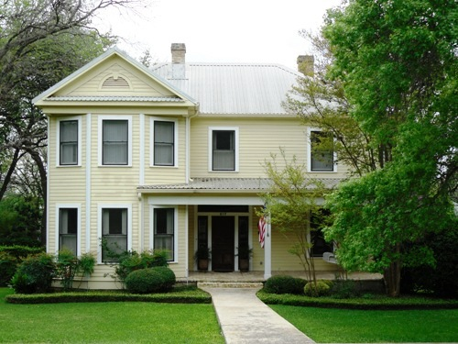
Only two families have called the house at 819 Belvin Street home since it was built in 1909. Reflecting the history and tastes of both the Montgomery and the Pennington families, the turn-of-the-century home will be one of five featured in the Heritage Society of San Marcos Tour of Homes May 5-6.
John and Cecilia Montgomery, the original owners of the home, were married in 1870 in a double wedding ceremony. Sharing the happy day with the couple were Cecilia’s twin sister, Civilia, and her husband, Joseph William Earnest. The wedding took place at the chapel of the Coronal Institute, the well-known Methodist School from that era, which was located on Belvin Street.
Cecilia and Civilia were the daughters of Charles S. and Savannah Cock, one of the founding families and landowners in San Marcos. Following the wedding, Cecilia and John Montgomery would spend their first years together in the Cock family home on Hopkins, now known as the Charles S. Cock House Museum. Visitors to the house today can see a photograph of the twin brides in their long white gowns as well as some wedding presents the Montgomerys received.
Civilia and Joseph Earnest were just a stone’s throw away from the Montgomerys in those early years of marriage, living just across the street in a house where the Parks & Recreation Building now stands.
In 1884, the Montgomerys moved to the Cock family farm in Maxwell, where they raised cotton and children. After a particularly prosperous cotton crop in 1909, the family decided to move back into San Marcos and build a new house there. Joe and Civilia had moved into a house on Belvin Street in 1895 (the home now owned by Bonnie and Ed Longcope) and the Montgomerys chose a lot next door to them, bringing the twins within a stone’s throw of one another once again.
The Montgomerys would raise their 13 children in that home, where they lived the remainder of their lives. Their children would retain ownership of the home until 1985, when the Penningtons purchased it.
While structurally sound at that time, the house showed its age and was in need of restoration. The Penningtons repaired some of the wood and installed some new windows. They also opened the back of the house, creating a new kitchen and dining area. The restoration work began in early 1987 and was finished after several months. In 1988, the newly restored home was featured for the first time on the Tour of Homes.
Listed on the National Register of Historic Places, the Montgomery-Pennington home is a two-story frame house in the classic-revival style. Topped by a hipped roof with an intersecting gable wing, the house features two brick chimneys and a one-story porch supported by simple Doric columns.
In restoring the home, Linda and Bill Pennington used original materials when possible or materials consistent with the era. Among the original features are a brass light fixture in the entry, heart pine floors, oak mantles in three of the downstairs rooms, side and top front door panels; and leaded glass in the transom and sidelights on the front entrance.
The two back rooms not original to the house are a butler’s pantry/kitchen and family room that reflect a more modern, Southwestern style with Mexican tile floors, built-in bookcases and a custom designed fireplace mantle.
With antiques and family heirlooms situated throughout, the house retains its turn-of-the century flavor while still offering modern comforts and style. On the Tour of Homes for the sixth time, the Montgomery-Pennington house will once again offer to visitors its tale of two great San Marcos families.
Article written by Shelley Henry
The Robert Hixon Belvin House  Home of  Gerald & Donna Hill  730 Belvin Street | 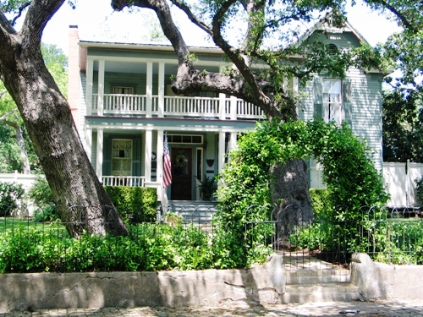
Originally a one-room school built in about 1859, the Robert Hixon Belvin House will be one of five stops on the 37th annual Tour of Homes May 5-6, sponsored by the Heritage Association of San Marcos.
One of the first schools built in San Marcos, the house, located at 730 Belvin Street, is not a typical Victorian home with “gingerbread” trim, although it does have a beautiful carved bargeboard on the front gable. The Reverend Robert H. Belvin, president and headmaster of the Methodist school known as the Coronal Institute, later converted the house into a two-story residence with a double front porch for his family.
In 1890 the house was purchased by the Reverend J. W. Vest, who again enlarged the home to accommodate his family. After the deaths of Rev. and Mrs. Vest, the house was sold in 1903 to Professor J. S. Brown, one of the first faculty members of what is now Texas State University.
There are many people who have lived in this house. During World War II, it was divided into five apartment units. Later the house was restored to a single family residence. In the 1970’s, the house underwent extensive remodeling and room additions by the family who owned it for approximately 18 years.
Each owner has added their own personality and special touches to the home. The current owners, Donna and Gerald Hill, bought the house in 1991 and expanded the property when they purchased an adjoining corner lot in 1998. That property became available after the house on the corner lot was destroyed by fire. The Hills added landscaping and fences to match those on their property. Last year they had the remaining old garage at the rear of the corner lot renovated into a guest house. They have had a great deal of landscaping done this year, including the addition of a large patio in the back yard using reclaimed bricks from Veramendi Plaza and the old hospital long ago located on Belvin Street.
Some of the more interesting features of the living area, which was the one-room school, include old three-inch long leaf pine floors in the living room, the antique door bell in the front door and a transom that dates back to 1875, and an oak fireplace mantel with beveled mirror that was originally in the historic Montgomery house on Belvin, owned by the Pennington family. Other unique features in the house include wide pine plank floors in the family room and master bedroom that were the walls of an old shed once located on the Morris family property next door. The kitchen has hand painted tiles and a trompe l’oeil (fool the eye) painting on one wall.
Bulls-eye molding is antique or milled to match throughout the house. There are special touches of antiques and collectibles in each and every room.

The Baker–McGehee Home  Home of  Dr. James & Mrs. Diana Baker  727 Belvin Street | 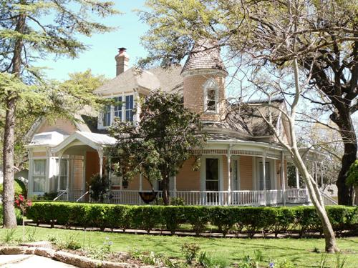
The Baker–McGehee home located at 727 Belvin Street is an outstanding example of Victorian charm and beauty. The home was built in 1895 for George Thomas McGehee and his wife Sarah Cherokee Woods. Cherokee was among the people featured in the book and made-for-TV movie “True Women.” George McGehee was among the first white settlers in the San Marcos area. George was born in Bastrop on February 5, 1836. The McGehee family moved to the San Marcos area in December 1846. In 1852, at age 16, George became a scout for Jefferson Davis who was the Secretary of State. As a scout, it was his job to furnish buffalo meat for the survey crews building the Southern Pacific Railroad. In 1862, as many men from San Marcos did, he joined the Confederate Army. He was a proud member of Company D, 38th Calvary, Terry’s Texas Rangers.
On May 12, 1872, George married Sarah Cherokee Woods. Sarah was the daughter of Dr. Peter C. Woods and Georgia Lawshe Woods. The Woods family moved to the San Marcos area in 1850.
Turrets were a common feature on Victorian homes, however, the Baker–McGehee home is one of only three turreted homes which remain in San Marcos today. The McGehees moved into the newly completed home and lived the remainder of their lives there, celebrating their golden anniversary in 1922. The two-story Victorian home has five rooms, a beautiful entrance hall and a back hall on the first floor. The second floor has two bedrooms and an added bathroom, as well as a double attic.
Today the home is owned by Dr. James and Diana Baker, who have carefully and painstakingly restored the home back to its original charm and beauty. Upon entry through the original front door, you are amazed by the beauty of the 14 feet wide entry hall with all the restored woodwork and architectural elements put in place by the first family of the home. The wallpaper is an exact match to what was placed there by the McGehees. The Bakers have also furnished the home with period Victorian pieces. If George and Sarah were to return to the home during the Home Tour, they would feel right at home and be pleased indeed.
Article written by Rodney van Oudekerke
The Syers–Secrest Home  Home of  Chris & Dina Secrest  719 West San Antonio Street | 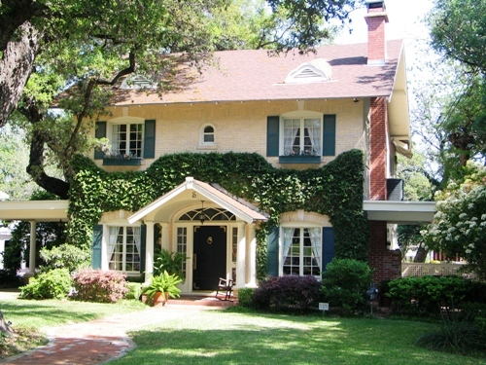
With its stately ivy-covered brick façade, the Syers-Secrest Home has graced historic San Antonio Street for almost a century. The house will be featured in the annual Heritage Association of San Marcos Tour of Homes May 5-6.
Visitors to the home at 719 W San Antonio Street will be charmed upon arrival by the brick walkway that winds through the landscaped front yard.
Since purchasing the home in 2000, owners Dina and Chris Secrest have kept it in the original condition with only a few recent modifications, including the addition of an exterior fireplace porch, new master bath area and new outdoor additions to include patios and a pool area.
Documentation of the construction date and building plans of the home, first owned by Edith and Jack Syers, is somewhat limited. The completion date was most likely between 1911, when the lot was deeded to Edith Syers by her father, and 1915, when newspaper articles make reference to the home.
John Buckhout “Jack” Syers moved from Illinois to Texas in 1898 and married Edith Donalson sometime between 1904 and 1911.
Jack was a sales representative for the National Cash Register Company for many years, but also became active in the life insurance business in the last 10 years of his life, representing the Jefferson Standard Life Insurance Company. He was a member of the Masonic order and served as steward in the Methodist Church. Jack died at home in 1941 after a lengthy heart ailment.
Edith Dorothy Donalson was born in San Marcos in 1881 to George Walter Donalson and Virginia Cormany. After marrying Jack Syers and settling in San Antonio Street house, Mrs. Syers was a homemaker and active in the Methodist Church.
San Marcos resident H.C. Kyle said he recalls Mrs. Syers was a thin woman with dark black hair who loved to dress in purples and lavenders and was pleasant, talkative, and always cheerful. The late Dr. Gwen Smith, who bought Mrs. Syers’ second house in 1977, found a truck filled with some of Edith’s things. These items spoke of a genteel social life-an evening gown and opera gloves, fine linens, and serving dishes and a man’s derby hat and tuxedo. Mrs. Syers attended the coronation of England’s Queen Elizabeth in 1953 and died in Dallas in 1961. She and her husband had no children.
Worthy of note is Mrs. Syers’ father, George Walter Donalson, and grandfather, Israel B. Donalson, were prominent early citizens of San Marcos.
In fact, George Walter Donalson owned a mercantile store at one time in San Marcos, briefly served as city alderman, and acquired hundreds of acres of farmland near Stringtown. He also had interest in the San Marcos Telephone Company, of which his son, George Walter Donalson, Jr., gained controlling interest in 1927.
A fire insurance map from 1922 indicates the original layout of the Syers house included only the two-story main portion with a small front porch. By the following decade, the house appeared more as it looks today, with an addition to the front porch, new side porches and the one-story, slate-roof porch extending halfway across the back of the house.
Covered with brick veneer, the house is believed to have been the only non-wood house on residential San Antonio Street at that time.
Mrs. Syers’ nephew, Walter Donalson, Jr., now 94 years old, remembers his aunt was quite a gardener. Her kitchen sink drained directly into her flowerbeds in back and an elevated cistern caught rainwater off the roof.
Edith Syers would continue to live in the house well after her husband’s death in 1941. When the stairs became too difficult to climb, however, she built a one-story home next door and sold her original two-story home in July, 1951.
From then, ownership of the house passed through five other families before it was purchased by the Secrests.
The Heritage Association of San Marcos featured the house in the 1986 and 1997 Tours of Distinction as well as on the Holiday Tour in 1997 and 2001.

