Home of  Barbara Trepagnier  903 West San Antonio Street | 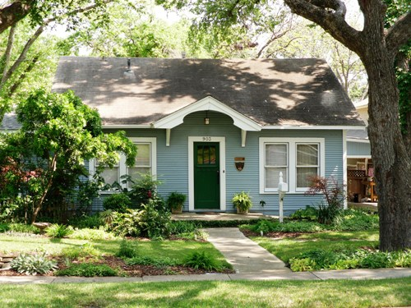
Have you ever wondered what diamond rings, gold watches, and the home located at 903 W. San Antonio Street have in common? They are proof that things of beauty come in small packages.
Built in the 1920’s, this Craftsman-style bungalow home, owned by retired Texas State University Professor Barbara Trepagnier, is truly breath-taking. The beautifully landscaped front yard is just a taste of what you can expect to see on the inside. Ms. Trepagnier's artistic talents and imagination are on display in every room.
The moment you walk through the front door, you will experience the welcoming feeling the home exudes. The front room of the home features open rafters on the ceiling and horizontal wooden plank walls. The floral fabrics and cottage-style decorating look ready to appear in a Better Homes & Garden magazine. A bedroom features torn paper on the walls, finished with a faux paint treatment.
Ms. Trepagnier has tastefully decorated her home with antiques and “near” antiques. One of the antiques of interest is the kitchen center work station. It is a Mexican table made in the 1860’s. Before finding its way into the kitchen of this home it was used in a South Texas tavern.
Older homes such as this one have one issue -- they rarely have enough closet or storage space. Ms. Trepagnier solved this problem by repurposing an old clothes wardrobe she found here in San Marcos at a second-hand store. Today it is used in the kitchen and houses brooms, mops, and various cleaning supplies. Another notable item is the antique Chambers cook stove which belongs to the homeowner’s parents.
The home’s backyard is equally impressive. The back porch features a fireplace mantle built in the 1850’s. The yard takes advantage of the great San Marcos weather by using several seating areas to create outdoor rooms. One of these rooms is the large circular flagstone patio which is furnished with comfortable Adirondack chairs as well as a custom made table -- a retirement gift from Texas State University for her years of dedicated service.
While standing on this comfortable patio, if you listen very carefully you may hear a faint cackling. Don’t worry, it is not the ghost of garden club members past. It is the joyful sounds of Ms. Trapagnier’s four pet chickens who supply her with fresh eggs daily in their custom hen house.
In addition to outdoor living areas, the backyard features a large greenhouse. Standing in this back yard, it is easy to forget you are in the middle of a small city (San Marcos). Instead, you feel as if you are visiting a well-manicured county estate.
This jewel will surely delight the senses of any visitor.
Article written by Rodney van Oudekerke
The Patterson Home  Home of  Ryan Patrick Perkins  727 West Hopkins Street | 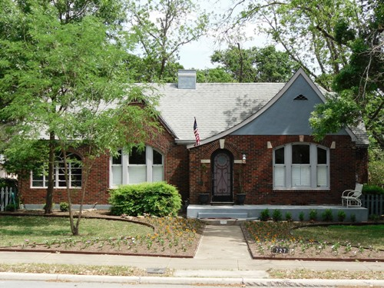
Featured on this year’s Heritage Home Tour is the old Patterson home located at 727 W. Hopkins Street. This beautifully maintained example of a “Tudor Style” Craftsman home belongs to the Frazier-Perkins family. Ryan Patrick Perkins actually grew up in the home with his sister Claire Elizabeth and recalls many fond childhood memories in this historic home.
The home, originally built in 1934, was for the Patterson family, not to move into, but rather a place for Mrs. Patterson to properly entertain when she was in San Marcos. Mrs. Patterson, a professor at Southwest Texas Teachers College became chair of the Home Economics Department and used the home to entertain and create gourmet meals in what was, by today’s comparison, a very small, yet functional kitchen. While the name of the actual builder seems to have been lost in history, it is believed they same person built two or three other homes in the same neighborhood; two homes on Hopkins near Scott and Blanco Streets, and a third home on Belvin Street near the intersection of Belvin and Veramendi Streets (note the similarities in the window, door, woodwork and roof designs). The home at 727 W. Hopkins maintains all its original brickwork, which was laid by the Paterson family’s friend, and local bricklayer, Max Shapiro.
The home features original beautiful handcrafted craftsman style woodwork and moldings, both inside and outside of the house. Walking up to the home you will notice the prominent arched windows across the front of the home. The arch doorways, inside and out, continue the theme set by the windows. Upon entering the home through the arched wood crafted front door featuring a round porthole, you cannot help but notice the oak hardwood floors, original to the home. The front room features a typical craftsman fireplace adorned with hand-painted tiles added by Ms. Frazier in the 90’s. Though the tiles are original to the home, the paintings are relatively new. Even so, great care was given to assure they were painted in the craftsman style. While keeping in mind that the home was originally built for a proper lady to entertain her guest, Mrs. Patterson’s formal taste can be seen in such details as the beautiful coffered ceiling featured in the front living room. The arches featured from the outside of the home continue through to the home’s interior doorways and window casings. Twelve-foot ceilings are seen in nearly each room throughout the home.
Originally a two bedroom, one bathroom house, the Pattersons added another bathroom adjacent to the second bedroom around the 1940s/1950s and is dated by pink subway tile on the floor, walls, countertops & shower. The original porch, now Ryan’s office, was once used by Mrs. Patterson to host tea & Tupperware parties; many of the neighborhood children, now adults, remember having her sandwiches, pastries and tea in her garden room overlooking the many other beautiful homes on the same block.
Mr. Patterson’s was a local merchant and farmer. The Patterson owned a grocery store here in San Marcos while living on a family farm close to Staples. It wasn’t until the Pattersons began to get older that they made a decision to sell the family farm in Staples and call their house in “the city” their permanent home.
The home on 727 W. Hopkins remained in the Patterson family until 1984 when former Hays County Treasurer Dottie Sims purchased the home as a gift for her daughter, Michele Frazier and her family. At the time of purchase the home had all original furnishings, paint and fixtures. Over time, as the historic homestead began to age; it seemed the best long-term solution to expensive repairs, and constant headaches, was a renovation, remodel and addition.
So, in 2004 great care was taken when the Frazier-Perkins family undertook an interior and exterior remodel and renovation in an effort to preserve the home while adding modern features and comforts for future generations. Although the original kitchen and breakfast nook were removed, Mrs. Patterson would be proud to know that the kitchen (by far the highlight of the renovation) was remodeled and enlarged for one specific reason: entertaining. The kitchen (now featuring a 5’X7’ granite island, butlers pantry, pullout cabinets, six-burner gas stove-top, double convection oven, wine cooler and French doors leading out to the back garden) was personally designed by Ms. Frazier, whom, like Mrs. Patterson is descended from a long line of talented chefs and proper hostesses.
Additional work included: replacing an original and worn out cast-iron tub with a Jacuzzi bath, moving outdoor laundry facilities indoor, and a wall once located between the kitchen, breakfast nook and dinning room was removed to create flow and add space. Again, great care was taken to ensure any new arched doorways were recreated to seamlessly match those originally found throughout the home’s interior. The Frazier-Perkins family made every effort to keep the charm & feel of a Tudor style craftsman home.
After attending Louisiana State University and living in well established historic and garden districts in Baton Rouge, Ryan returned to San Marcos in 2008 and moved back into his family home with the energy and enthusiasm to continue preservation efforts started by his mother & grandmother.
In addition to the stunning architectural features throughout the home you will notice several family antiques (some spanning back five or more generations), which have tastefully been used to make the home feel even more comfortable & cozy. As well as the antiques, one will notice several pieces of stunning artwork and photography. Ryan’s father (O.C. “Tyke” Perkins) was a professional photographer who shot several covers for Texas Monthly Magazine; many of his original works can be seen throughout the home.
The Heritage Association of San Marcos is certain you will enjoy this one of a kind Tudor style craftsman home.
Article written by Diane DuPont-Marlow
Anna Lee’s Viola Street Inn  Owned by  Anthony & Kerry Rash  714 Viola Street | 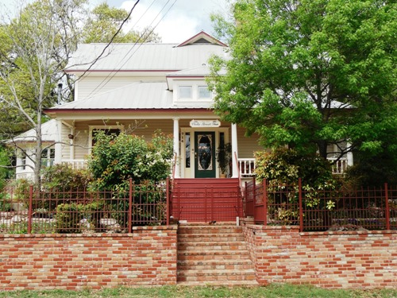
When George and Ola Smith built their home at 714 Viola it only had 1200 square feet. Today that same home has 4,000 square feet. That is because the owners of the home, Tony and Kerry Rash, saw the potential in the little run-down structure they bought back in the 1980’s. The house was slated for demolition after being literally gutted. The plans were to remodel and re-sell. Whatever the intentions were, they soon changed. Tony and Kerry fell in love with the house and learned their family was about to get larger by one. In order to make this little 1200 square foot home into a large family home, Tony added the entire second floor. Today words like “re-purpose” and “recycle” are common but not so in the 1980’s. The Rashes on the other hand, saw the benefit from repurposing antique lumber, windows and bricks. Tony, a master craftsman, did all the mill work throughout the home. The magnificent staircase has quite a history all by itself. The newel posts on the staircase, which look as if they are fine antiques, were actually salvaged from a water bed.
A fine brick and iron fence graces the front of the home. Tony salvaged the bricks from the old Stonewall County Courthouse in Aspermont, Texas, and hauled them to San Marcos.
The house is tastefully furnished with both newer and antique pieces of furniture. Most of the antiques are family pieces from Tony’s and Kerry’s families.
The original home is solid wood construction. The cap and crown mouldings are original long leaf pine salvaged from the home and then hand-planed by Tony and replaced. The baseboards and door trims are antique wood collected from various estates across south Texas. The flooring in the foyer is original.
The dining room features reupholstered and refinished furniture that belonged to Kerry’s grandmother. On special occasions the table is set with fine English China that bates back to the 1700s.
Today Tony and Kerry welcome overnight guests to their beautiful home which has been repurposed once again. Welcome to Anna Lee's Viola Street Inn Bed and Breakfast.
Article written by Rodney van Oudekerke
Home of  Patrick M. Rose  627 West San Antonio Street | 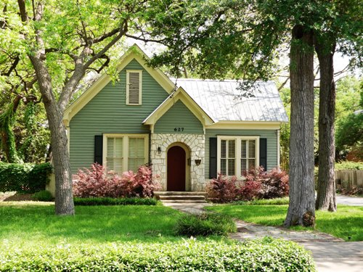
Warm afternoons strolling the sidewalks sheltered by the spreading arms of the aging trees that line San Antonio Street bring back visions of life in a less-hurried time. Ice cream socials, boys playing with tops, and neighbors visiting on the porch all capture the spirit of small town America in the early 20th Century. The American craftsman style and bungalow are traditional classics, but perhaps the best description of the blue and cream house of this genre on the corner of West San Antonio and Jackman Streets is simply charming. The Tudor style house, built in 1905, has incredible curb appeal, and the unique arched red front door invites you into a comfortable haven. The simply elegant home has two bedrooms with two full baths as well as a comfortable living area, dining room, spacious kitchen and extra sitting room. It boasts 15 foot ceilings, arched windows, plantation blinds, and some of the original and beautifully restored hardwood floors.
In recent years, a series of owners have called the cottage home. Ruby Slaughter occupied the home until Rufus Alexander purchased it in 1994. Subsequently it was sold to Bill and Nancy Kilte who made extensive renovations and improvements including removing a back porch and expanding the kitchen and sitting area. They also added the master suite at the back of the home and an additional bathroom. They faithfully maintained the architectural integrity of the original structure. Ownership of the home then passed to Randall Morris and later to Ryan and Jenny Frisbie who sold it to the current owner, Patrick Rose, last year.
Patrick had often admired the home and always loved the San Antonio Historical District neighborhood. He adds, “The house was a perfect fit for me. I love the neighbors and my street. It has a wonderful energy about it.” Patrick moved here from his hometown of Dripping Springs. The busy young professional said he had wanted to make San Marcos his home for quite some time, adding: “The combination of the University, the community as a whole, and its location gives San Marcos a breadth that makes it a very attractive place to live and work.”
In keeping with the traditional appeal of the home, there are several interesting objects of special significance to Patrick including several family pieces and sentimental memorabilia. The dining room table served as his desk for many years as he studied through law school, prepared for the bar exam, and detailed his plans to start a new business, Corridor Title. Also on display are family quilts patiently pieced and quilted by his maternal grandmother, Ella Barton. Several pieces of furniture have been passed down from his paternal grandmother, Margaret Hoffman Rose. One of the most sentimental gifts to Patrick was a gift given to him at age 12 preceding his paternal grandmother’s death -- a baseball presented to her on her 18th birthday and signed by Lou Gehrig and Joe DiMaggio.
Whether it is a brisk Halloween night with goblins racing from house to house, a cheery Christmas Eve with strolling carolers from a nearby church, or a balmy late Spring day with a glass of cold lemonade in hand, life is still pleasant on San Antonio Street as a new generation of homeowners appreciate its legacy and preserve its enduring charm.
Article written by Diane DuPont-Marlow
The Dobbins–Neese Home  Owned by  Don & Sandi Neese  416 Blanco Street | 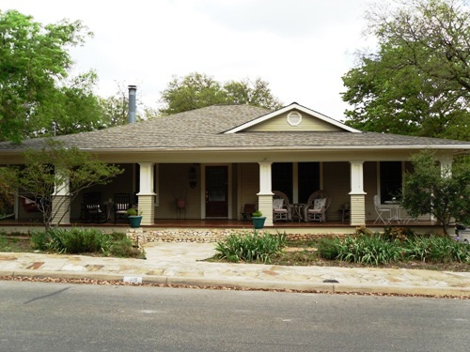
The Dobbins/Neese home at 416 Blanco Street in San Marcos is a Craftsman-style home that originated as a duplex built around 1922 by D.K. Beasley for his wife. The Beasleys never occupied the home as reportedly Mrs. Beasley did not like the style of the house.
Ed Dobbins Sr. and his wife Ada along with young daughter Betty Jeanne bought and moved into the home in February of 1923. At that time the house was a single story duplex with a bedroom on either side of a joint kitchen and living area. Two rooms at the front of the house were a formal dining room and a formal living room. At the rear of the house was a small bath and breakfast room that had been a back porch. The very front of the house was spanned by a large covered porch.
Around 1935, now having a 5-year-old son, the Dobbins began a series of extensive renovations, adding an additional bedroom, a full bath, whole house attic fan system and automatic in floor gas heaters. These additions along with appliance upgrades, new tiles and wallpaper continued until the restrictions on buying construction materials were brought on by WW II.
The house remained this way until 1974 when one of the in-floor gas heaters caused a fire that gutted the center of the house. The house was rebuilt essentially the way it was to current building codes with a modern kitchen, new plumbing, air conditioning, carpeting and new wiring.
In 1985, Edward Jr. bought the home from his parents and moved in with his wife Rosemary. They set about their own remodeling/renovation scheme by enclosing the side porches and creating an art studio on the south side and a photography dark room on the north side.
In 1987, Edward Jr. and Rosemary moved to Alabama due to a job change and began renting the home. In 1989, the Neese family moved in after selling their home in Southridge and began searching for a home in San Marcos. Over time, Sandi began to see a lot of potential in the home and imagined ideas for new landscaping projects. In April of 1995, Don and Sandi Neese purchased the home and set about an extensive list of remodeling projects.
The interior of the house was essentially gutted, removing walls and widening doorways. All carpeting was removed and new hardwood flooring was installed as most of the original was destroyed in the 1974 fire. The formal dining room and a few other small spaces are the only original floors remaining. The original wood walls were all covered with sheetrock and new moldings, wood doors were installed and pocket doors where possible. Rosemary’s art studio was changed into an office area with the installation of a custom built two-person desk and Edward’s photography studio was transformed into a home project/gift wrapping area. The house is a comfortable open plan that is used for entertaining family and friends. The house is always evolving and changing and is loved by the current owners.
Article written by Don Neese
The Thomas House  Owned by  Mike & Cathy Dillon  322 West Hopkins Street | 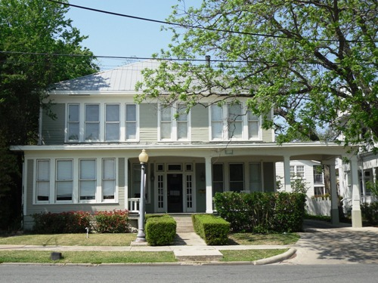
This imposing dwelling is now a jewel in Crystal River Inn’s collection of buildings, but such a harmonious state of affairs was a long time coming. When innkeepers Mike and Cathy Dillon first bought their original inn building in 1984, its next door neighbor, the Thomas House, was on the market and badly in need of renovation. But one of the inn’s many early challenges was that the very week the Dillons moved in, so did the Thomas House’s new owners….a fraternity!!! The boys were as shocked at being put in a place they’d have to be civilized, as the Dillons were at the prospect of drunken parties on their doorstep. Fortunately that group went broke, and for a time the house was partly filled with quiet professional offices.
Then, in 1990 the Dillons received some sudden scary news. A veterinarian from out of town was about to place a contract on the by-now derelict building, with plans to turn it into an animal hospital…..not quite the ideal neighbor for the lovely, peaceful bed and breakfast inn they were working so hard to create.
With visions of barking dogs and angry guests, the Dillons swung into battle mode, only to find their protest options nonexistent. Because the block was zoned commercial, there were virtually no restrictions on what businesses could be allowed. “Honestly,” remembers Cathy, “someone at the city told us a meat-packing plant could be put there and we couldn’t do a thing about it.” Finally they concluded that only one thing could be done: buy it themselves. Fast.
That didn’t at first endear them to the frustrated veterinarian, but it did open the doors to a solid partnership that endures to this day. First renting the Thomas House from the inn, and then some years later finally buying it, Dr. Jeff Jorgenson moved both his family and his business into the building. They did an extensive, creative remodeling job and lived there for almost 18 years, dodging the ghost in the upstairs front room and thoroughly enjoying life in downtown San Marcos. When Dr. Jeff moved his practice out to Hunter Road in 2007, the house entered its next phase as part of the Dillon's now-thriving inn.
Built in about 1915, the structure features many elements of the Craftsman style: distinctive square pillars, a deep porch, wide eaves, gentle roof slopes, built-in cabinets, and lots of beautiful dark woodwork. However, the classic Craftsman is a simple single-story bungalow. Very rarely is this architectural style used for a building as large as the 3-story, 5500 square foot Thomas House. Upon entering you cannot help but be impressed by the beautiful original staircase which invites you to the second floor of the home where you will notice yet another staircase. This one, however, is a contemporary metal spiral that leads to a third story loft apartment.
Jack and Florence Peacock Thomas built the home to house their family of 7 children after they moved here in 1909 to place the children in the San Marcos Baptist Academy. Thomas was a career builder-developer who had twin San Marcos legacies: he donated the Hutchison Street land on which his beloved First Baptist Church was built, and he developed both the West End and Westover subdivisions. Though the Thomas House is no longer a single family home, you still get that “welcome home” feeling from the gracefully aged worn wooden hardwood floors and beautiful wooden trim work throughout the structure.
It is easy to imagine a family being raised here. You can close your eyes in its central hallway, and almost hear the laughter of the 7 children who once called this huge place home. It is not difficult at all to imagine walking home from a nearby church on Sunday and sitting down to a fried chicken dinner. The Thomas House reminds us of a time that may not have been easier but certainly moved a little slower.
The home remained a single-family dwelling into the 1940’s. After that it spent several decades as a boarding house before the fraternity emerged on the scene. It has been remodeled numerous times through the years, and the Dillons would like to interview anyone with memories or knowledge of how it may have looked originally.
Its third-floor loft now houses a private apartment for inn staff. The second floor has 4 guest bedrooms for the inn; and the ground floor offices are mostly spa services (hair, nails, massage, body work, electrolysis, facials, and makeup artistry). Behind the Thomas House is the 1500 square foot Carriage House, which really was a livery in the early years. And adjacent to both buildings are the inn’s event courtyard, tent, and gardens, set up today for one of the many weddings held here every year.
Article written by Cathy Dillon

