2010 Home Tour
Home of  Andrew & Teresa Hobby  1231 West San Antonio Street | 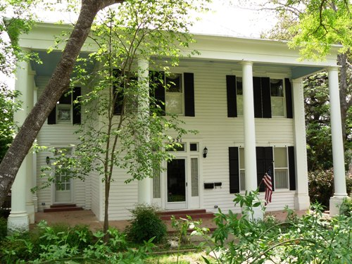
This home was built in 1908 for Gustave Voges and his fiancé, Nettie Perkins Leary. Gustave came to Hays County in the late 1800s and was the son of German immigrants who settled throughout the hill country area. Gustave and his brother, Adolph, owned confectionaries in the Billingsley and the Hofheinz hotel.
C.M. Waldrip and his wife, Mattie, bought the home from Gus and Nettie Voges in February, 1944. The Waldrips made it a home for 10 years until they sold it to Joe Wilson in 1955. The home was later bought by John and Elizabeth Morrisset in 1972 and restored to its original beauty with upgrades.
Teresa and Andrew Hobby bought the home from the Morrissets in November, 1995. They have made it their own by introducing some modern touches in the old style. The two-story house has four bedrooms, three upstairs and one down. In 2004, they added a bathroom downstairs with Victorian-style decorating and a claw foot tub.
The house has special cypress wood siding on the outside that was brought in from south Texas. It still has the original wood floors and tile in the additions.
The Hobbys have tastefully decorated their home with period antiques as well as an eclectic collection of pieces from around the world. They are particularly proud of the family pieces from Andrew Hobby's grandmother, Oveta Culp Hobby, which she obtained on her trip to the Orient in the 1950s.
Article written by Mackenzie Hollas
The Barbee–Dake Home  Home of  Dr. Theodore Jr. & Mrs. Thea Dake  220 North Johnson Avenue | 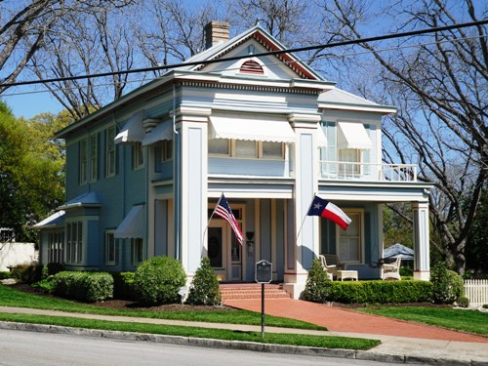
Located in the heart of the Belvin Street Historic District is the elegant and graceful home built in 1906 by J.H. Barbee and owned today by Dr. Theodore Jr. and Mrs. Thea Dake. J.H. Barbee was a veteran of the War Between the States, serving on the confederacy side during the conflict. He was once described as a”promoter,” a man involved in banking, cotton, real estate, and building houses -- successful at all of his ventures. J.H married his sweetheart Abbie King, the daughter of a prominent local farmer.
Over the years the Barbee home located at 220 North Johnson Avenue has been owned by a number of prominent people. Each one of families left its own subtle but unique mark on the home. In 2001 the current owners bought the home. The Dakes spent years renovating both the inside as well as the outside of the home to return it to the elegant and graceful Victorian home is was meant to be. They have carefully and lovingly added or restored many architectural antiques in the home such as stained, etched, and beveled glass. They have returned the crown molding, marble hearths, and light fixtures using period pieces. Guests enter the home through the front foyer which is crowned with a beautiful German hand cut crystal chandelier. The foyer fireplace has a petticoat mirror above it. After all, a proper Victorian lady would never leave the house unless all was perfect. The petticoat mirror was used by the ladies to check their skirts as they descended the formal staircase. Hanging on the wall at the bottom of the formal staircase is a six foot Vienna regulator clock dating back to 1870. Very notable features of this home from both the inside as well as the outside are the beautiful stained glass windows which face Belvin Street. It is believed that both these windows are Tiffany windows. The formal dining and living rooms are separated from the front foyer by very unusual pocket doors -- their very large size uncommon for this particular era. The hand cut French crystal chandelier in the dining room is also very unique. The chandelier and matching crystal wall sconces were designed and put together by Thea at the factory in France.
Wonderful antiques fill the home, most from the mid to late 1800’s. However, be sure to look for the hand-carved oak chair, a beautiful work of art dating back to 1775. Classic elegance fills every room, accompanied by an inviting warm atmosphere.
Article written by Rodney van Oudekerke
The Lavender-McGaughy Home  Owned by  Karen Tellepsen  826 West Hopkins Street | 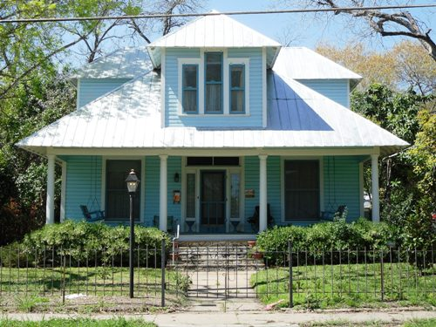
Is there any thing better than going to Grandma’s house? For most, the answer is no. If it has been too long since you were able to visit your grandma’s home, you will definitely want to visit the Karen Tellepsen home at 826 West Hopkins Street during this year’s Heritage Home Tour. Stepping into the home immediately takes you back to a time when things were a simpler, and moved at a slower pace.
The home was built in 1909 for E. King Lavender and his wife, Sadie. The Lavenders came to San Marcos from Tennessee in the early 1900’s. Mr. Lavender worked in San Marcos as a hat salesman. Local lumberyard owner J.W. Webb was hired to construct the Classic Revival “pattern house,” which he did in three months’ time. E. King and Sadie occupied the home until 1912 when it was sold to the widow Josephine McGaughy. Josephine and her son lived in the home for over 40 years. In that time, Josephine’s son Douglas became a dentist and had a practice in San Marcos for many years.
In 1954 the home was once again sold, this time to Professor Jack Rosenbaum, who was a professor at Southwest Texas State University. The Rosenbaums lived in the home for a little over twenty years. In 1999, the current owner Karen Tellepsen knew this was what she was looking for. A math teacher in Houston, Tellepsen wanted a second home where she could be closer to her daughter and son-in-law, Ellen and Jeff Ault, and grandsons -- a home where the grandchildren could experience all the blessings of being close to Grandma, such as home-baked cookies and cakes, and stories from the “olden days.” Tellepsen is able to keep part of the family legacy alive for her grandchildren by preserving the old telephone operator’s station once used by her father in the family construction company. You can see the station in the back part of the home today. Over the past hundred plus years, this home has kept its charm with the high ceilings, Texas pine hardwood floors, and original doors.
Another focus in the house will be on needlepoint. The dining room features the homeowner's needlepoint: the table centerpiece is a collection of crosses, the sideboard contains a village of shops, and the buffet is filled with angels. There are needlepoint pillows in every room with a jungle of needlepoint and crewel animals in the "bunk bed" room. The kitchen walls are garnished with needlepoint pictures. Mrs. Tellepsen hopes you will enjoy the fruits of her handiwork.
Quality craftsmanship and a lot of love have maintained this house over the years. Thanks to the restoration efforts of Karen Tellepsen and the love that only a grandma can put into a home, this home will be around for many more generations of children to enjoy.
Article written by Rodney van Oudekerke
The Baker–McGehee Home  Home of  Dr. James & Mrs. Diana Baker  727 Belvin Street | 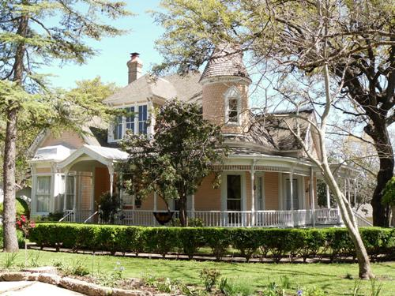
The Baker–McGehee home located at 727 Belvin Street is an outstanding example of Victorian charm and beauty. The home was built in 1895 for George Thomas McGehee and his wife Sarah Cherokee Woods. Cherokee was among the people featured in the book and made-for-TV movie “True Women.” George McGehee was among the first white settlers in the San Marcos area. George was born in Bastrop on February 5, 1836. The McGehee family moved to the San Marcos area in December 1846. In 1852, at age 16, George became a scout for Jefferson Davis who was the Secretary of State. As a scout, it was his job to furnish buffalo meat for the survey crews building the Southern Pacific Railroad. In 1862, as many men from San Marcos did, he joined the Confederate Army. He was a proud member of Company D, 38th Calvary, Terry’s Texas Rangers.
On May 12, 1872, George married Sarah Cherokee Woods. Sarah was the daughter of Dr. Peter C. Woods and Georgia Lawshe Woods. The Woods family moved to the San Marcos area in 1850.
Turrets were a common feature on Victorian homes, however, the Baker–McGehee home is one of only three turreted homes which remain in San Marcos today. The McGehees moved into the newly completed home and lived the remainder of their lives there, celebrating their golden anniversary in 1922. The two-story Victorian home has five rooms, a beautiful entrance hall and a back hall on the first floor. The second floor has two bedrooms and an added bathroom, as well as a double attic.
Today the home is owned by Dr. James and Diana Baker, who have carefully and painstakingly restored the home back to its original charm and beauty. Upon entry through the original front door, you are amazed by the beauty of the 14 feet wide entry hall with all the restored woodwork and architectural elements put in place by the first family of the home. The wallpaper is an exact match to what was placed there by the McGehees. The Bakers have also furnished the home with period Victorian pieces. If George and Sarah were to return to the home during the Home Tour, they would feel right at home and be pleased indeed.
Article written by Rodney van Oudekerke
The Pitts Malone Home  Home of  Jim & Doni Weber  715 Belvin Street | 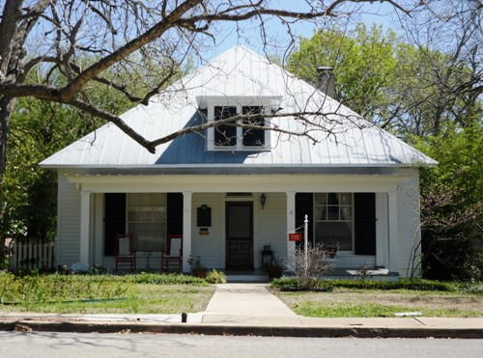
Located at 715 Belvin Street, this beautiful historic home was built in 1909 for Eliza Pitts Malone. Upon its completion, Mrs. Malone occupied the home with her unmarried daughter, Bramwell Malone. Like most of the homes in the San Marcos historic districts, the Pitts Malone home has a pier and beam foundation, using 12-inch cedar piers for the foundation and heart of pine beams. The original home consisted of five rooms downstairs and a large unfinished attic.
The youngest daughter born to John and Eliza Pitts, 10-year-old Eliza came to Texas with her parents in 1842 from Macon, Georgia. John Pitts served as the Adjutant General of Texas. On July 4, 1847, Eliza and her cousin Sarah Pitts sewed and presented the first Texas flag to be flown over the Hays County Courthouse. Eliza was very close to her cousin Sarah. Eliza was Sarah’s bridesmaid when Sarah married Willie Randle on June 6, 1848, in the first wedding ceremony held in San Marcos. Eliza was a charter member of the First Methodist Church of San Marcos.
In 1850, Eliza married James Lafayette Malone. The couple had 16 children. During the War Between the States, 1861- 65, Eliza ran the family’s 1,000 acre farm, tended to the children, and, to do her part for the war effort, sewed uniforms for the local Confederate soldiers. After John died, Eliza had this smaller home built for herself and her daughter. Eliza was 82-years-old during World War I. Even then she felt the need to serve her country. Her contribution to the war effort this time was to knit socks for American soldiers. On February 6, 1923, Eliza Pitts Malone died at the age of 91. Her funeral was attended by 156 direct descendants.
In 1924, her daughter, Bramwell, affectionately known as “Miss B,” purchased the former Lange Flower Shop on North Austin Street, changed its name to Malone Floral Shop, and, in 1932, moved the shop to the Belvin Street home. For years, courting couples in San Marcos relied on Miss B’s shop at 715 Belvin Street to provide them with corsages and bouquets. Bramwell continued to live in the home until her death on March 20, 1959.
Following Bramwell’s death, the house was updated, the attic room finished, and central heat and air added. Subsequent owners, most notably Mr. and Mrs. William Daniels, who bought the home in 1979, added other touches to make the house more comfortable, all the while maintaining its historic integrity. A large back veranda was added in 2005, and it is one of the features most enjoyed by the present owners.
Today the home is owned by Doni and Jim Weber, who fell in love with the home the moment they entered it in the summer of 2007. The Webers have found that fine balance between historic preservation and comfortable modern living. The once unfinished attic is now a comfortable office for the Webers, as well as a spacious guest suite. While keeping the historic charm and character, the home has a large modern kitchen and comfortable family room. This home has something for everyone to enjoy: fine historic structure, modern comforts, art featuring local and regional artists, and a rich San Marcos history.
Article written by Rodney van Oudekerke
Delta Zeta  Sorority House  403 North Street | 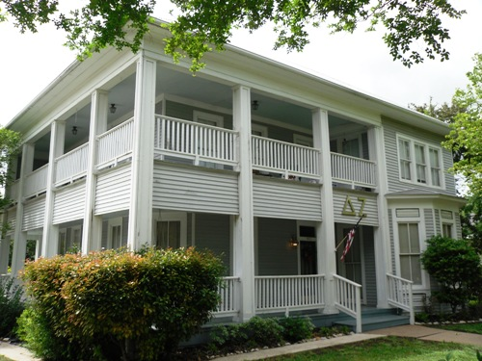
George Washington slept here. Well, maybe not the father of our country but a George Washington, nonetheless.
Not much historical information is known about this century-old Victorian home located at 403 North Street. It is known that either the original owner or a very early owner of the home was a railroad man by the name of George Washington. However, the house speaks for itself architecturally. This beauty can hold its own against its sisters on Belvin and Burleson Streets.
The home features two wrap around porches on the first and second floors, with inviting rockers and a swing on which to enjoy a glass of iced tea on a warm summer evening. As expected for a home of this caliber, the windows are floor-to-ceiling to allow for optimal airflow. A large original portion of the house is still intact, but additions have been carefully blended to provide functional space with minimal interruption of style. There are quaint formal rooms for entertaining visitors, as well as large rooms to accommodate daily meals and meetings.
The Delta Zeta Sorority has done a great job of preserving the home’s historic charm while encouraging the young ladies living here to add their own individual decorating style. The large windows, high ceilings, bull’s eye and crown molding, and original wood floors evoke memories of an earlier era. The bedrooms, however, are decorated in thoroughly modern coed style: lots of hot pink, lime green, turquoise and zebra prints. Visitors will see that living in a Victorian home does not mean one has to live like a Victorian.
The Heritage Association of San Marcos is proud to include the Iota Alpha chapter of the Delta Zetas on this year’s home tour.
Article written by Rodney van Oudekerke
First United Methodist Church  129 West Hutchison Street | 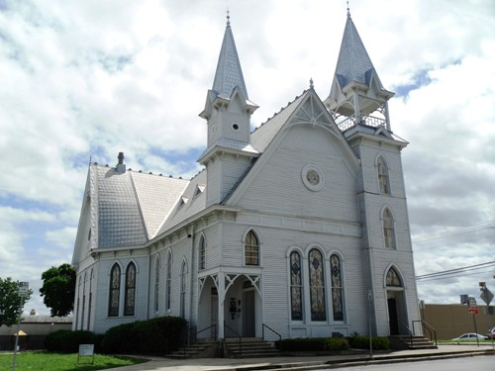
In 1847, the log cabin which was the home to the John D. Pitts family was used to organize the San Marcos First Methodist Church. Beginning with nine charter members, the church has continued to grow for over 160 years in San Marcos. The very recognizable structure on W. Hutchison Street is over 120 years old. The first preacher of the church was a circuit rider named A.B.F. Kerr. Kerr would later become the first mayor of the city of San Marcos. The current structure is actually the third building of the congregation, not counting the Pitts home. In 1855, the congregation joined with the Masonic Lodge to construct a two-story structure to be shared by the Masons on the second floor and the Methodists on the first floor. Thirteen years later the building was destroyed by fire. In 1872, a red brick structure was built for the church. The bell hanging in the bell tower today is the same bell used in the brick structure. This brick building had to be torn down after 19 years of usage due to shifting ground which caused severe structural foundation problems. The present building was completed in 1893. This beautiful Victorian building is built in the “Carpenter Gothic" style. It is in the shape of a cross. The wood used in the building is cypress and cedar, with a pier and beam foundation.
Inside the church today, you will see the original walnut pews, pulpit and alter rail. Some of the pews still have wire hangers under them where the gentlemen would place their hats upon entering the sanctuary. In 1911, the balcony which is still in use today was added to the church to add additional seating to the growing congregation. The church has the bragging rights of having the first pipe organ in San Marcos. The organ arrived at the church in 1912 at a cost of $3,500. To put this in perspective, all the pews, the pulpit, and the alter rail, as well as the chandelier which hangs over the alter, only cost $75 total in 1893.
In 1981, the congregation raised money to completely restore the building. At a cost of almost half a million dollars, the shingles were reproduced using the old ones as molds, the four-story bell tower which had been closed up for many years was reopened to expose the beautiful antique bell, the stained glass windows were removed and re-leaded. The paneling was removed to expose the original bead board walls visible today.
From that little group of nine members meeting in the John D. Pitts log cabin, The First United Methodist Church of San Marcos has grown to be one of the largest and most active churches in San Marcos.
Article written by Rodney van Oudekerke
The Fourth and Present  1909 Hays County Courthouse  111 East San Antonio Street | 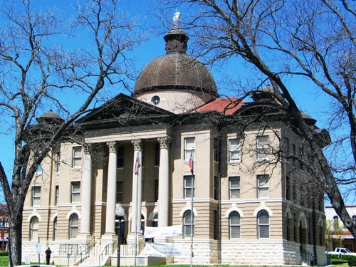
The Hays County Courthouse was designed in the Beaux-Arts style by C.H. Page and Brother. Built in 1908, it is the fourth courthouse of Hays County; the other three were all destroyed by fire. The courthouse square has been the center of Hays County for over 130 years. The rotunda is accessed by four grand entrances. The roof is topped with Lady Justice, as a symbol of the county officials’ responsibility. Due to unstable roof conditions, she was removed in the 1980’s. Visitors will be told many stories, from the incredible statue of Captain Jack C. Hays to secrets discovered during 1990 restorations.
The original Hays County Courthouse was built on a forfeited bond of $2000. Mr. John M. Bright was charged with the murder of “Mr. Stanley” in 1853. Little is known due to loss of Travis County records, but according to newspaper reports, Mr. Bright was found guilty of manslaughter in Travis County on April 2, 1853 and sentenced to one year’s labor in the state penitentiary. A petition was presented to Governor P.H. Bell who granted a reprieve. Mr. Bright was scheduled to be tried again, with the trial being moved to Hays County. On April 21, 1854 Mr. Bright did not show for court and the $2000 bond went into the Hays County coffers.
This gave the county the money to build. The building was 53’x45’ with one courtroom, two jury rooms and four offices. A fire in late 1868 was believed to be arson, but no one was ever charged.
Courthouse number two was opened in 1874. On July 31st, 1876 at 2am, fire was spotted coming from the County Clerk’s office. A bottle of kerosene was found near a pile of legal papers, probates records, deeds and mortgage records that were all destroyed. A bare footprint was found on a door that also had chisel marks where it was forced open. Although Governor Richard Coke offered a reward, no one was ever convicted. Eventually the building developed such serious structural flaws that iron bands had to be placed around both floors. Stones from that courthouse still curb the lawn today.
The last of the 2nd courthouse building was removed in 1881 and the cornerstone of the third courthouse was set on June 13, 1882. It was designed by the renowned architect Frederick Ernst Ruffian, who also designed UT’s Old Main. At the cornerstone ceremony, it was estimated that 2000-4000 people came for the occasion. February 12, 1908 the courthouse was on fire again with pictures taken at 4:30 a.m. showing the entire 2nd floor engulfed. This time, because the County Clerk’s office had been moved adjacent to the courthouse (on the east side) and the county records were housed in a fireproof vault, legal records were not lost. It was reported by local historian Eddie Serur that the fire was started by embers blown from fires in north San Marcos.
The cornerstone for the current building was laid on November 23, 1909. By the 1980’s the building was in such bad disrepair that visitors were advised not to lean against handrails. In November 1993, voters approved a $1.8 million bond package. With the addition of a $2.2 million grant from the Texas Department of Transportation, many features were restored, including the reopening of all four entrances. Besides maintaining the historic architecture, the building was modernized and brought up to fire and disability codes.
Today, visitors can enjoy this restored architectural treasure which anchors the downtown square and invites all to explore San Marcos, the Hays County seat.
Article written by Linda Coker

